Davis Portable Buildings
- 12x20 Loft Barn
- 6ft Stud Walls
- 3-4 ft loft
- 24inch deep shelves
- Ramp
- Wiring is included
- Residential Door to enable climate controlled and pest free environment
- Siding: 50 Year Warranty (if maintained every 5 years)
- 1 Year Warranty on craftsmanship
- Shingles: 30 Year Warranty
- Metal Roof: 45 Year Warranty
- Pressure treated materials
- Build on site to obtain taller walls and loft

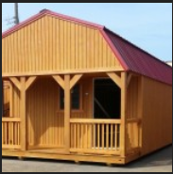
12 X 20 Building | $4,498
Outlets (2)  Overhead Light  Switch  Wired with Romex | $875
36” Door | $85
8ft Walls | $200
Built on Site | $300
Treated Ramp | $475
Treated Flooring | $150
TOTAL | $7,903
TAX | $711.27
Total with Tax | $8,614.27

